**Internship Title:** UI Frontend Intern

**Company Name:** Link Development

**Introduction**

This report entails the activities, skills and experiences that I have gained during my internship at Link Development in the summer of 2019. This report includes the main contents of the internship for evaluation. The objective behind this internship is to get introduced to the frontend section of my field of study and to be able to compare my strengths in both the frontend and backend divisions of my major which is important in shaping my future career plans. In this report, I will be covering the company description, the internship activities including assigned tasks and the working environment, my evaluation of the internship and conclusions I made by the end.

**Company Description**

Link Development is an A15 company. It is a global technology solutions provider leading the digitalization of private and public sectors. It was founded in 1996 and operates in +24 countries through four offices in Egypt (HQ), UAE, KSA and Italy. They offer their customers integrated, inventive and digitally productive experiences essential to their business transformation that blend cloud, analytics, mobility, smart services, Dynamics 365 - CRM, infrastructure, IOT, augmented reality and others. They assist their customers in taking the digital leap from strategy to realization by providing digital strategy and roadmap consultancy; build immersive, creating business transformation platforms and delivering sustainable business optimization solutions.

*“We believe that the primary role of technology is to create a digitally productive world. Therefore, we are driven by a passion to build solutions, initiatives and programs that digitally empower, connect and transform the lives of employees, students, citizens, entrepreneurs and other stakeholders in the IT community at large.”*

They are also a multi-award winner with their +20 years of expertize, +600 professionals and thousands of successful engagements across different industries such as Governments, Real-Estate, Healthcare, Telecom, Finance & Banking, Aviation and Education. They are partners with leading software solutions providers such as: Microsoft, K2, AvePoint, Informatica, esri, OutSystems, Nintex, verba, Aquia, Sitecore, Unite4, IdeaScale, RealDolmen, ODC, Sonus, proMX, Veeam and Dell.

Mailing Address: 94, Street 105, 11431 Maadi

Website URL: <https://www.linkdevelopment.com/en-us/>

**Internship Activities**

* ***Assigned Tasks***

1. *HTML, CSS, JavaScript Knowledge (Research, Reading and Learning Tutorials)(main source: freeCodeCamp)*
   * Responsive Web Design
     + Basic HTML & CSS
     + CSS Flexbox vs Grid
     + Applied Visual Design (like manipulating elements, visuals, animations,…etc)
     + Element & Media Responsiveness
     + Accessibility Principles & Standards (not in detail, brief intro)
   * JavaScript Algorithms & Data Structures
     + Basic JavaScript
     + Introduction to ES6
     + Data Structures Review
     + Basic & Intermediate Algorithm Scripting (exercises to recap on concepts and learnings)
     + Object Oriented vs Functional Programming
   * Frontend Libraries
     + Bootstrap (introduction)
     + JQuery
2. *Implementation through Project (Barwa Website)*
   1. Extraction of icons/fonts/images and recording of precise and detailed measurements of all elements using Photoshop
   2. Creating a customized font library for icons
   3. Building website structure using HTML and basic CSS
   4. Adding functionalities to elements according to website requirements
   5. Implementing necessary animation using JQuery to ensure smooth UI
3. *Tools and Equipment*
   * Photoshop
   * Icomoon website
   * Visual Studio Code
   * Google Chrome (viewing and inspection)

* ***Working Environment***

At the beginning, all new recruits (mostly new employees and only myself as an intern) were given an introductory session that introduced us to the company in detail (history, position in the market or map, getting to know the important personnel we could come in contact with) along with necessary information (company policies, benefits and ethics). Official working hours for interns were 9AM-4PM and more flexible to employees where they can arrive anytime between hours of 9-11AM but must complete 7-8 hours of work (monitored by PC sign in attendance tickets). In the Frontend team, the employed parties were 15 including the department manager. For the first two weeks prior to the Eid El-Adha Holiday, I was asked to conduct a research and training boot-camp into all the necessary frameworks, tools and concepts that I would use in the main project (Barwa Website). I was not constrained to a certain guideline or forced into a specific approach, but rather given advice on the platforms I should go to and the liberty to do so in the manner I was most comfortable and most effective with. After the 3 Day Holiday, I immediately began working on the website in which I mainly used HTML, CSS and JavaScript including JQuery. I was aided throughout by my mentor as well as other members of the Frontend team regarding concepts I couldn’t fully grasp that they explained, advice on decisions regarding the project and feedback of my work including comments for improvement. As per the company’s new agile strategy, multiple sessions for certain departments were conducted every week or another to bring updates to employees, offer solutions for problems faced by the entire department or introduce something new to be adapted in their work. Some of the sessions were **ADOBE XD vs ADOBE Photoshop**, **Photo Gallery & Form Template** (this session opted front-enders to use the enivra gallery lite plugin instead of the gallery plugin and introduced a new form template which is a SASS component that acts as a collection of all form items (ex. textboxes, dropdowns, passwords, uploads, calendar,…etc) that could be used to make it easier, save time & exert efforts in personalization rather than research) & **GEM** (the team that was part of the Grand Egyptian Museum gave the session and introduced the new website created for the museum, how the old one looked along with comparisons, how they improved it, challenges faced with the clients and how they overcame them).

**Internship Evaluation**

This opportunity has taught me a lot about my field of study. I learned about frontend development which is drastically different from my usual focus on backend. So much detail goes into the final product that I only became aware of once I was put to the test to create my own project. Even though I was alone as an intern, I was quickly welcomed into the environment I was in and other employees have offered their services to help me gain as much from my short stay at the company. I learned to express myself and not to hesitate when in need of help. This internship was very beneficial and has definitely made me consider frontend and UI design as a possible path in my career. I was advised to add Graphic Design to my learning bucket as it would make me a much more powerful frontend developer. I only wish I had more time to work more on the website (get introduced to frontend frameworks like React, Vue and Sharepoint) and complete it. I would definitely recommend this internship to my colleges even if they never considered frontend as an option because it truly is an eye-opening experience.

**Report Conclusion**

This internship has taught me to always welcome new and unfamiliar opportunities. The computing major is a wormhole with countless fields and areas. It’s very important to keep updated about the newest trends and technologies that are produced every day in the world of computer science. Needless to say, there is a constant need in the market for programmers and the more studies they’re armed with, the more they’re demanded. For a software house like Link Development, you are met with challenges every day and that is what keeps a programmer’s mind brewing. There is nothing tedious about pushing yourself to exceed expectations and help bring the client’s vision to life, no matter how difficult it may seem at times. That is why it’s important to never stop the loop of learning no matter where you are in your career but to continue adding more knowledge.

**Appendices**

* + - 1. The .psd file received from the graphic designers for the design of the website

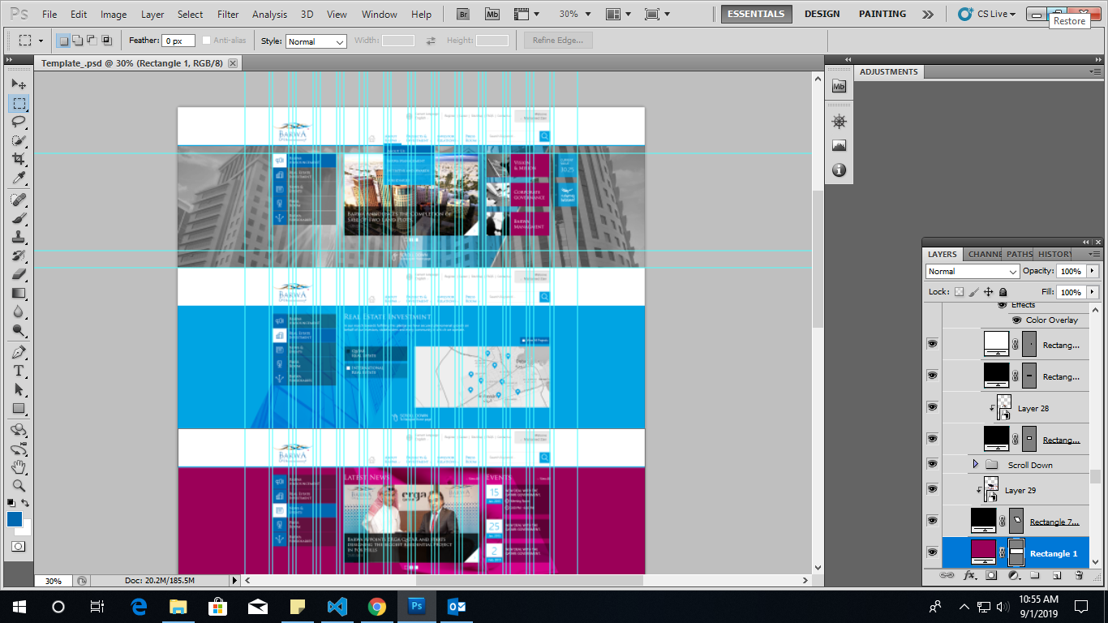

* + - 1. A closeup of the details in the design

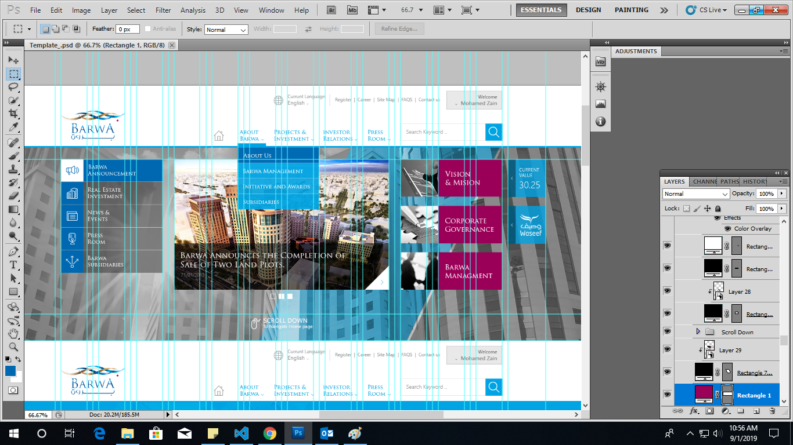

c) sessions’ schedule for Q3

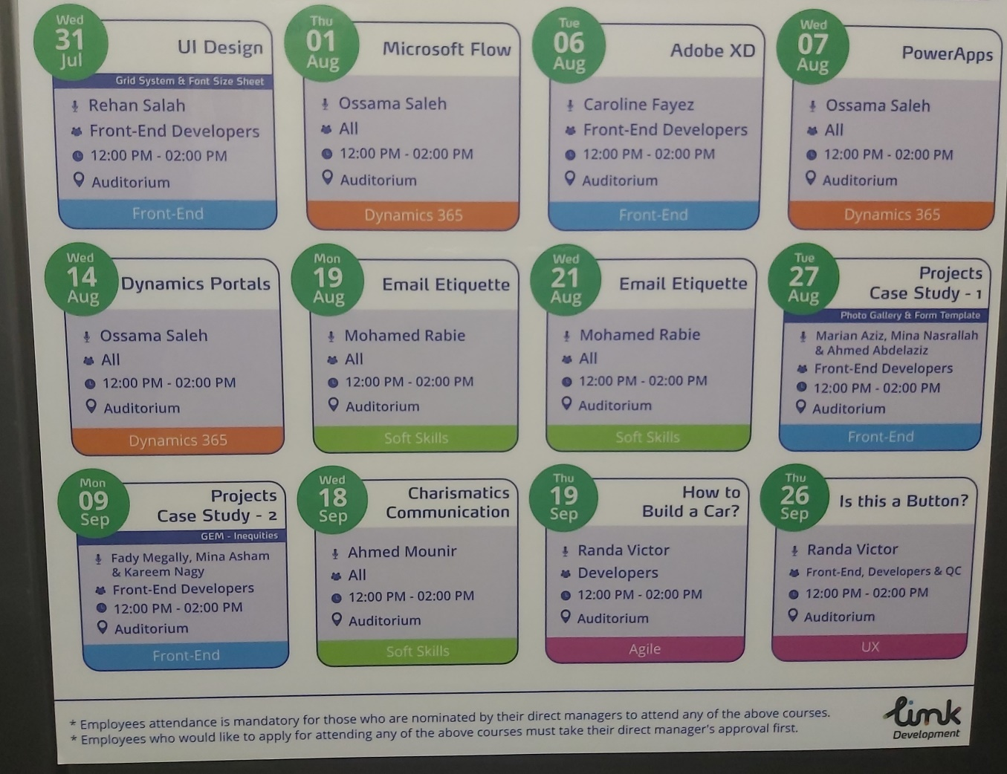

* + - 1. 3 screenshots from my final product/design

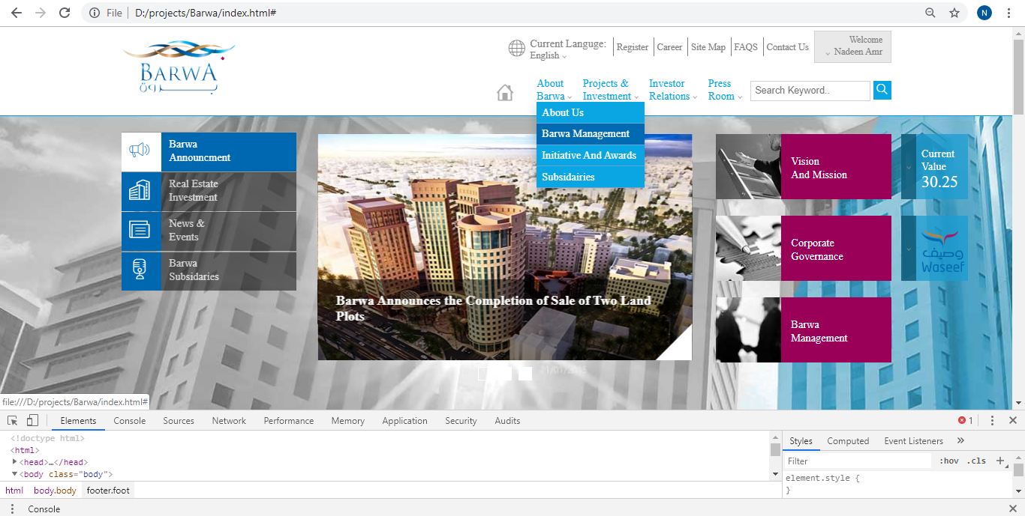

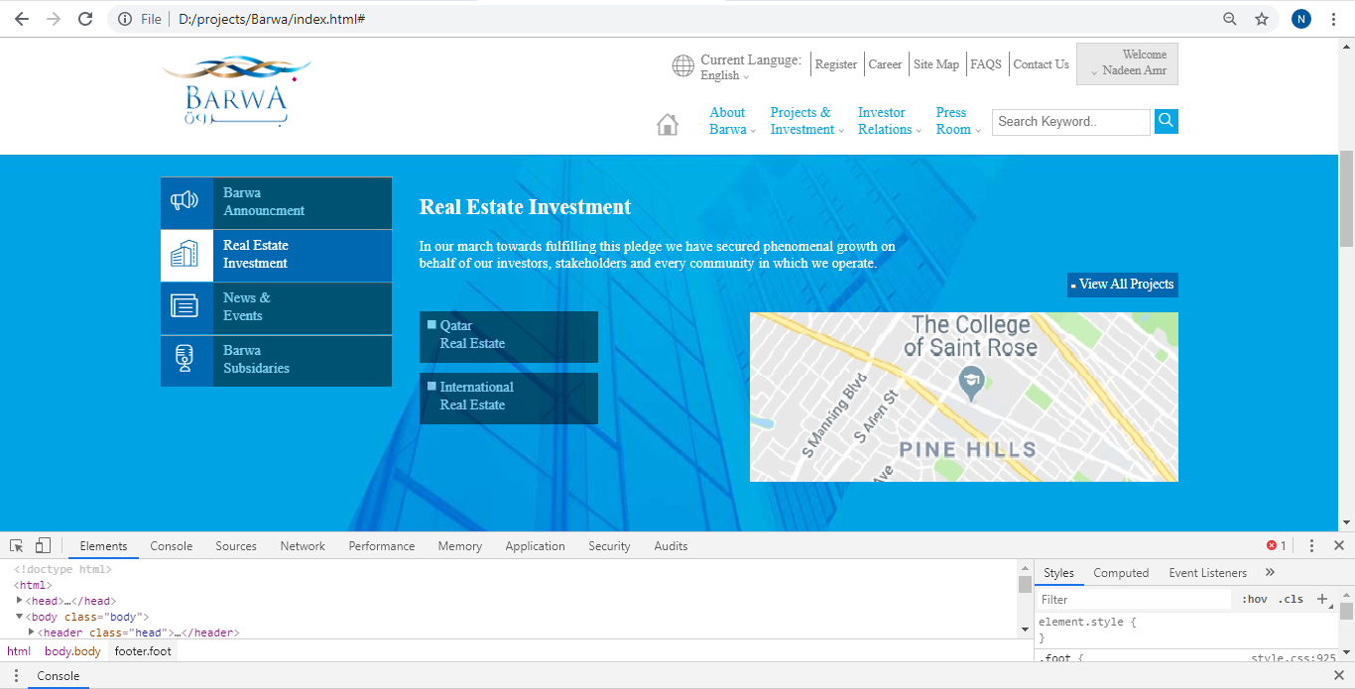

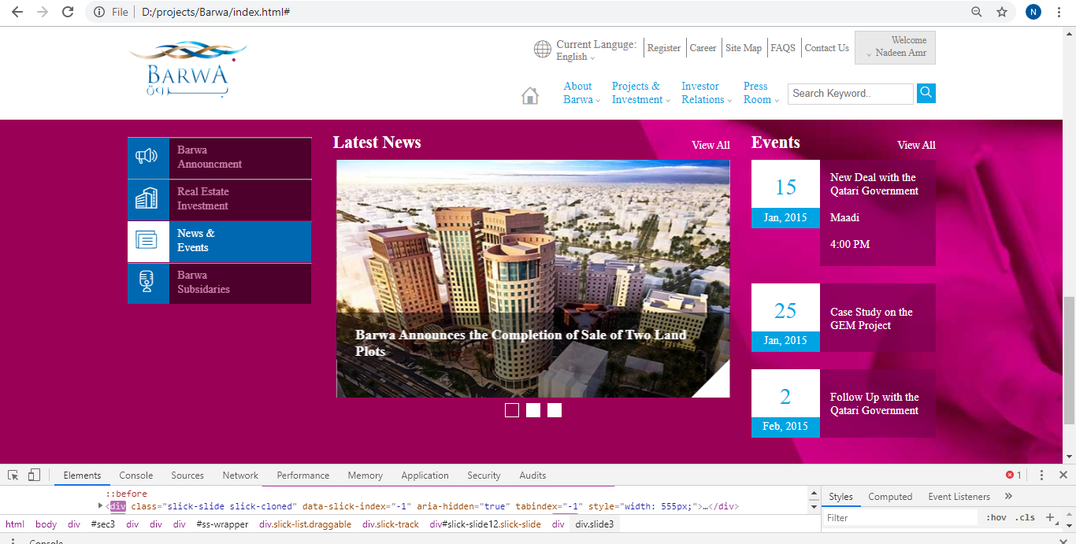

**References**

<https://www.linkdevelopment.com/en-us/> was used to get more information about company for description